PCI DSS Compliance in a State-Wide Clothing Chain
Trevor M. Pelfrey
Western Governors University

Table of Contents
Summary 3
IT Solution 11
Implementation Plan 13
Review of Other Work 14
Project Rationale 18
Current Project Environment 19
Methodology 20
Project Goals, Objectives, and Deliverables 21
Goals and Objectives 22
Project Timeline with Milestones 24
Outcome 25
References 26

Summary
Johann and Sons is a growing clothing company in the state of California. The company is made up of 26,000 employees, all of which work within the state, with orders coming in from all over the North American continent. Johann and Sons has recently began to process enough transactions a year that it has moved into Payment Card Industry Data Security Standard (PCI DSS) level 1. PCI DSS level 1 requires that a corporation complete a Report of Compliance (ROC), Approved Scanning Vendor (ASV) Scan, and an Attestation of Compliance (AOC). Due to a combination of security incidents and compliance requirements, it was necessary to do an assessment to assure that the network was compliant.

The sample for this compliance assessment is one of the company's most successful and oldest stores, used as a model for how others in the company are set up. The store was set up in early 2014, using second hand equipment where possible to keep costs down. It was set up in a single unsegmented wireless mesh network that had little hardware change since it was set up in 2014. There were two TP-Link TL-WA701ND Wireless Access Points (WAP) and one DPC3939B Comcast Business Wireless Gateway within the store’s network, covering the whole of the store as well as parts of the neighboring buildings. One of these WAPs are used to connect the Lightspeed Point of Sale (POS) systems at the front of the store. The other WAP is used in the stockroom to connect scanners to the Inventory Management System, but employees are known to use personal devices to connect for personal internet access. All of these are setup to use Wired Equivalent Privacy (WEP), a deprecated wireless security standard that is easily brute forced by modern hardware.
There is a firewall setup between the modem and the gateway. Firewall rules were set to allow only certain incoming traffic, but allowed all outgoing traffic. The store has a server rack with modules running a MYSQL server, a HTTP server, an implementation of Fishbowl Inventory Management System utilizing the previous two servers, a network attached storage setup, a video surveillance system using the network storage to store footage and wireless cameras covering most angles in side of the store and out. The network attached storage and the Windows 10 PC used to facilitate most admin duties both have Norton Antivirus installed. Outside of transitions performed on the POS devices, there would be no storage of Payment Card Data. Other services essential to store operations not mentioned are performed via cloud services appropriate for each need.
The store was never subject to an external penetration test. While there is an IT support specialist employed by the store, the specialist was often loaned out to other stores to assist with their technical problems and keep costs low, with primary focus on maintaining network functionality over security concerns. Patching for software and hardware systems is performed every second Friday at low traffic hours of the work day. The IT support specialist performs vulnerability analysis using OpenVAS, though the IT support specialist wasn’t aware of any of the compliance functions or how to use them. While Runbooks and Playbooks exist, there is rarely anyone with the technical knowledge to use them.
Staff training as it relates to handling cybersecurity threats however is relatively up to date, including focus on potential attack vectors they may be subject to including phishing and shoulder surfing. This training happens once at hiring and then every year after around early October. Further bolstering the security posture is the use of Gmail and Slack for business communications internally and externally, the earlier of which having protections against phishing. A visitors log is kept by the manager for external visitors to backroom areas.
Following a series of incidents, Johann and Sons had hired an external cybersecurity company to test the security at the model store. Logs on the WAPs and Wireless Gateway indicated that a brute force attack on the store’s Wi-Fi network had occurred, likely from the neighboring coffee shop. This security hole would be used at a later date to connect to the internal web front end for the database of clothing stock and drop a number of entries from the database via a SQL injection attack. While backups of this database exist in a cloud Infrastructure as a Service (IaaS) implementation, restoration from backups costs the store both time and money.

As it relates to the scenario, the PCI DSS 4.0.1 document was used to assemble the following table. The purpose of the table is to provide the requirement number violated, the general violation, and an explanation of how it violates that requirement:

Requirement | Violation | Explanation
1.2.1 | Network Security Controls Are Not Configured or Maintained Properly | Network Security Controls (NSCs), must be properly configured and maintained to meet security standards. The lack of outbound firewall rules would likely violate this, as outbound connections could include those not intended such as a bad actor connecting to a company machine via reverse shell.
1.3.2 | Outbound Traffic from Card Data Environment (CDE) is Unrestricted | Outbound traffic for the CDE, which encompasses the entire network because it is unsegmented, is explicitly allowed. Under 1.3.2, traffic from a CDE should not be allowed unless it is necessary.
1.4.1 | Connections Between Trusted and Untrusted Networks Are Not Controlled | Because the lack of segmentation puts the entire network into the scope of PCI DSS requirements, all instances of this must be considered. The brute-force attack on the Wi-Fi network indicates a violation of this requirement, but so does the lack of firewall rules for outbound traffic.
2.2.1 | Configuration Standards Do Not Address Security Vulnerabilities or Use Industry-Accepted Hardening Standards | The use of WEP for cryptography violates this requirement, as it is neither secure nor considered an accepted hardening standard in the modern day.
2.2.2 | Use of Insecure Default Configuration | Using default configuration gives attackers an edge in system penetration. While the password was changed, the default WEP standard is no longer sufficient for maintaining a secure network and should have been changed.
2.2.7 | Administrative Access is Not Encrypted With Strong Cryptography | Because all network traffic goes over the WEP encrypted mesh network, all traffic including that of the administrative access is insecure by default.
2.3.1 | Use of Insecure Wireless Configuration | Using default configuration gives attackers an edge in system penetration. While the password was changed, the default WEP standard is no longer sufficient for maintaining a secure network and should have been changed.
4.1 | Use Industry Best Practice Cryptography for Authentication and Transmission of Payment Card Data | Default settings for older WAPs often include WEP, which is an encryption standard that has been cracked. Modern systems with the correct software can easily break WEP, making this standard obsolete as a method of encryption.
4.2 | Primary Account Number (PAN) isn’t protected by strong cryptography | Default settings for older WAPs often include WEP, which is an encryption standard that has been cracked. Modern systems with the correct software can easily break WEP, making this standard obsolete as a method of encryption.
5.1 | No Malware Detection Process | There was no specific process for protecting ALL systems within the Payment Card Data environment.
5.2 | Malicious Software is Not Detected or Addressed | There was no specific process for protecting ALL systems within the Payment Card Data environment.
5.3 | Malware Detection Process is not actively maintained or monitored | Logs are dispersed through a number of systems, reducing the ability to actively maintain a malware detection process. Even if there were a Security Information and Event Management (SIEM) and or Intrusion Detection / Prevention system (IDS/IPS) setup, the infrequent availability of trained personnel to review logs and maintain security would still be a problem.
6.3 | Security Vulnerabilities are Not Addressed or Identified | WEP being a default configuration for early versions of certain WAPs, indicates either that the software on the WAPs weren’t updated or that WEP is being used purposefully. It is more likely the earlier than the latter.
6.5 | Changes to System Components are Not Managed Securely | In the recent breach, the SQL database had entries dropped by an unidentified entity.
7.1 | No Process or Mechanisms for Restricting Access to System Components and Cardholder Data | The network is unsegmented, meaning that when employees connect their phones to the Wi-Fi, they could potentially access cardholder data in transit. Being that this rule is conditional on business need to know, most of these employees connecting their phones to surf the web don’t need to know.
7.2 | Access to System Components and Data is Inappropriately Defined and Assigned | Employee personal devices are connecting to the Card Data Environment when they shouldn’t need to. Most of the network would not be included under the purview of CDE if it were segmented.
7.3 | Access to System Components and Data is Not Managed via Access Control System | The one IT Technician that is assigned to this location is not often available to manage access controls or otherwise enforce security policies.
8.1.1 | Security Policies and Operational Procedures for User Identification and Authentication are Undefined or Not In Use | Lack of personnel to enforce authentication policies. IT Technician is rarely on site.
8.2.1 | Users are Not Assigned a Unique ID Before Accessing System Components or Cardholder Data | Business environment should be used for business or otherwise segmented to secure cardholder data and other business data.
8.2.8 | Idle User Session Does Not TimeOut After 15 Minutes | There was no mention of session timeout. Would be irrelevant if network segmentation was used.
8.4 | No Multi Factor Authentication When Connecting to The Card Data Environment | No specific mention of Multi-Factor Authentication usage. Would be irrelevant if segmentation was used.
10.3 | Audit Logs are Not Protected from Destruction and Unauthorized Modification | Using a device connected to the network, one could potentially brute force any of the devices and destroy logs. There exists no backups for them like what would be provided by an Intrusion Detection System(IDS) or Security Information and Event Management(SIEM) System.
10.4 | Audit Logs are Irregularly Reviewed for Anomalies and Irregular Activity | The one IT technician assigned to the store is constantly on loan to other stores, leaving little time for review of logs.
10.5 | Audit Log History is Not Retained or Available for Analysis | There was no specific retention policy for audit logs.
11.4 | Internal Penetration Testing is Regularly Performed, and Exploitable Vulnerabilities and Security Weakness are Not Corrected | An internal vulnerability scan from the OpenVAS installation would have picked up on WEP being a vulnerability.
11.5 | Network Intrusion and Unexpected File Changes are Not Detected and Responded to | There existed no Network Intrusion Device on the network to defend against unexpected file changes. Log files should be sent to a server separate from the device they came from so that if intrusion takes place, the logs may still be used as evidence and to patch security holes.
12.3 | Risks to the Cardholder Data Environment (CDE) are Not Formally Identified, Evaluated, and Managed. | Because the CDE encompasses the whole network, and network transmission is done using WEP, it could be said that the risk to the CDE is unmanaged.

Lack of Network Segmentation: While not a requirement, the lack of network segmentation for payment card data puts the whole network into the scope of PCI DSS requirement testing, increasing costs, difficulty of PCI DSS control maintenance and risk to the organization as it relates to not only payment card information, but data security as a whole.

IT Solution
Before coming up with a solution to the network's insecurities, we should look at what the most frequent issues are before continuing. As compliance is the goal, we are going to be focusing on how often certain problems break PCI DSS requirements. The problems are outdated standards, lack of network segmentation, lack of network protection systems, and lack of qualified professionals maintaining the network. As we are covering IT solutions in this section, only the first three shall be discussed.
The issue that resulted in the security breach was the use of WEP. A temporary fix for this would be to update the firmware of WAPs and change their encryption standard to WPA2, as that is the latest standard available to the TP-Link TL-WA701ND. This specific wireless access point is very old at this point, being introduced back in 2012 and has since been put into end of life. Replacing those access points with more modern ones that support WPA 3 would be a good idea.
One problem that expands the scope of compliance testing and decreases security is the use of a single unsegmented Wi-Fi network. Wireless networks are more vulnerable to traffic capture techniques and allow the attacker the option of setting up an evil twin attack. With this in mind, a wired setup can be more secure and will save on Wi-Fi compliance testing costs over time. Utilizing Virtual Local Area Networks (VLANs) to segment the network into parts that need to connect to each other is the most logical and cost efficient solution for this location. The network may look something like this with all access being denied by default:
VLAN Name | IP Range | Contents | Access Restrictions
Card Data Net | 192.168.100.0/24 | 3 Point of Sale Systems | Can communicate with Firewall
Stock Data Net | 192.168.90.0/24 | HTTP Server, SQL Server, Inventory Management Server, | Can communicate with Firewall for scheduled cloud backups every friday night, receives communication from Scanner Net during work hours
Log Net | 192.168.80.0/24 | SIEM | Allows Syslog and SNMP traffic from all to Log Net  Allows logs to be sent to SIEM
Employee Net | 192.168.70.0/24 | Employee Personal Devices | Allows web connections outside of company blacklist when connecting through firewall
Scanner Net | 192.168.60.0/24 | Scanners | Can Communicate with HTTP and Inventory Management System
Cam Net | 192.168.50.0/24 | Cameras, Video Surveillance System | Connects to Storage Net to store footage
Storage Net | 192.168.40.0/24 | Network Access Storage
As implied by the above solution, the use of an Intrusion Prevention System (IPS) and Security Information and Event Management (SIEM) solution would allow for better optimization of staff time scanning logs, as well as potentially preventing access to malicious actors. A SIEM installation aids in compliance by centralizing and backing up logs for long term storage, as well as allowing further investigation by technical staff. An IPS could have detected and blocked the SQL injection attack on the internal front end, preventing any lost information and enhancing security posture.
Implementation Plan
Seeing as one of the issues was lack of qualified employees working on the store network, it would be worth considering contracting some aspects of the IT workload to other companies, so that Johann and Sons may build an inhouse IT staff while maintaining compliance and security posture. As this flawed network was used as the example for all other Johann and Sons stores, it is safe to assume that most of them will need to be brought into compliance. Where internal IT Support staff aren’t available, a Managed Service Provider(MSP) contracted to bring networks into compliance would likely be best. While large, Johann and Sons has a relatively simple network setup for their model store, which means that the planning period is going to be much shorter than businesses of its size may typically take. With this in mind, it may take two to three weeks for the completion of an onsite survey and assessments of what changes need to be performed to get the network where it needs to be. Deployment of the envisioned solution may then take a further one to two weeks, leaving a potential five week implementation period, after which general management of the network will be taken care of as dictated by the Service Level Agreement(SLA).

Review of Other Work
PCI DSS v.4.0.1: In PCI DSS v.4.0.1, the Payment Card Industry Security Standards Council outlines all of the requirements and sub-requirements for achieving compliance with PCI DSS, and thus maintaining the ability to process credit card transactions on your network. By providing detail on the requirements, the PCI DSS allows a competent networking team to proceed with making modifications to their network to increase compliance, potentially reduce testing costs, and further increase the security posture of a given network. This intent is outlined within the document under the section “PCI DSS Applicability Information,” where the council says that “PCI DSS is intended for all entities that store, process, or transmit cardholder data (CHD) and/or sensitive authentication data (SAD) or could impact the security of the cardholder data and/or sensitive authentication data. This includes all entities involved in payment account processing — including merchants, processors, acquirers, issuers, and other service providers” (p. 4). While the intent is that merchants that process card payments use this framework to achieve compliance, it can also be used as a reference sheet for general network security where applicable.
Key Reinstallation Attack: Breaking WPA2 by Forcing Nonce Reuse: KRACK is a vulnerability in WPA2 that affects all devices using the encryption mechanism. It is essentially a man-in-the-middle attack that uses a clone of a Wi-Fi network that the user has previously connected to force any HTTPS connections to become HTTP instead, making the password and username for any potential logins visible. According to Mathy Vanhoef, a professor at KU Leuven in his article on the discovery of KRACK attacks, “Our attack is especially catastrophic against version 2.4 and above of wpa_supplicant, a Wi-Fi client commonly used on Linux. Here, the client will install an all-zero encryption key instead of reinstalling the real key. This vulnerability appears to be caused by a remark in the Wi-Fi standard that suggests to clear the encryption key from memory once it has been installed for the first time. When the client now receives a retransmitted message 3 of the 4-way handshake, it will reinstall the now-cleared encryption key, effectively installing an all-zero key. Because Android uses wpa_supplicant, Android 6.0 and above also contains this vulnerability. This makes it trivial to intercept and manipulate traffic sent by these Linux and Android devices” (Vanhoef, 2017). As it relates to the current network implementation, the TP-Link devices have a proprietary operating system that works off of a Linux base, meaning that they are likely just as vulnerable as any other Linux device. Having been end-of-lifed years ago, the TP-Link TL-WA701ND WAPs do not have updates that would be necessary to fulfill security needs.
Network Segmentation Cheat Sheet: This document from OWASP details the principles behind network segmentation, how it can prevent unauthorized access to database servers and how it can prevent device control via Command and Control servers. The most important part of this for the purpose of this paper was the section on secure logging. OWASP suggests that “it is important that in the event of a compromise of any information system, its logs are not subsequently modified by an attacker. To do this, you can do the following: copy the logs to a separate server, for example, using the syslog protocol, which does not allow an attacker to modify the logs, syslog only allows you to add new events to the logs” (OWASP, n.d.). The setup suggested prior to reading this paper would not have captured all network logs, meaning that the logging process would have been incomplete.

MSP vs MSSP vs MDR Providers: Understanding Key Differences for Business Security Needs: When looking for information on the best approach to take for implementing the proposed network diagram, it was concluded that internal staff alone may not be sufficient for the purpose of achieving compliance and maintaining store infrastructure. This article from Proficio was of great use for understanding options available for outsourcing network design and maintenance. For the use case of this store’s network and potentially other stores on Johann and Sons network, it would appear that contracting an MSP and or an MSSP would be a good call, as both would reduce the potential workload on IT staff, allowing them to focus on other tasks such as physically setting up networks. the specific use cases for an MSP and MSSP as mentioned in the article are to “Stabilize and optimize IT operations, often through proactive management to prevent disruptions” and “Reduce the burden on organizations by minimizing the need for extensive recruitment, training, and retention of security personnel while ensuring a strong security posture” (Profico, n.d.) respectively.

Project Rationale
Meeting PCI DSS requirements is necessary to process payments via credit card. In an increasingly digital society where people rarely keep paper currency on them, credit and debit cards have become the primary methods of payment for consumers. Without the ability to process credit card payments, a company may lose a number of customers to lack of payment flexibility. Failure to maintain PCI DSS compliance for merchants accepting card payments may result in fines levied by card companies that range from $5,000 to $100,000 a month until compliance is re-established. By far the largest reason for attempting to remain compliant with PCI DSS is to attempt to prevent situations like the 2013 Target data breach that resulted in a $18.5 million settlement due to PCI DSS non-compliance. That situation led many customers to stop shopping at Target due to fear of their information being stolen and used by criminals to drain their accounts.

Current Project Environment
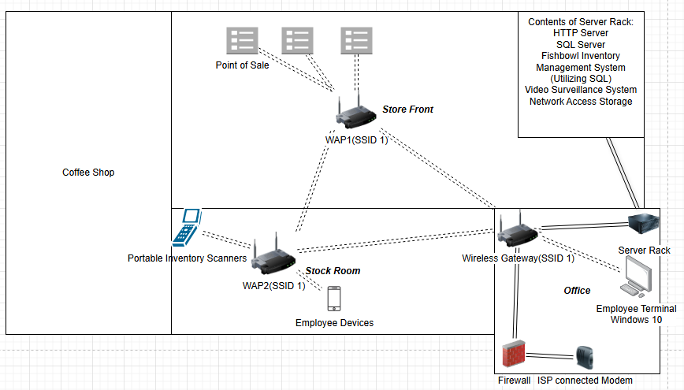
Pre-Assessment Network Diagram
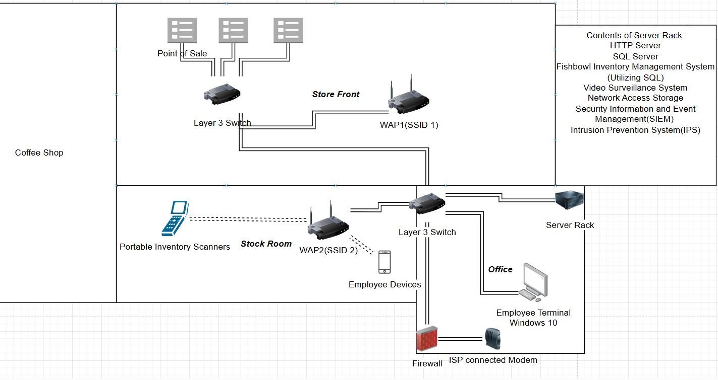Post-Assessment Suggested Network Diagram
Methodology
PCI DSS 4.0.1 covers testing methods for PCI DSS Requirements in section 10 of the document. The methodology is broad as to be applicable to as many networks as possible. It boils down to three elements: Examine, Observe and Interview.
Under Examine, the assessor evaluates data evidence critically. This is applicable to existing evidence within an environment, such as audit logs and configuration files. As it relates to the current scenario, this would include such things as the logs on the WAPs with indicators of compromise.
Under Observe, the assessor watches an action or something in the environment. This could include personnel performing tasks, computer components performing actions or responding to input. As it relates to the scenario, the lack of IT personnel maintaining the network or testing and seeing if the wireless networks encryption is vulnerable might be under the purview of Observe.
Under Interview, the assessor will attain information from personnel on operations, as well as how well they understand the environment technically. As it relates to the scenario, it could be said that the lack of IT personnel and the mention of a data breach are under Interview.
Most of this section is common sense. Items checked and personnel interviewed must be relevant to the requirement and the implementation of the assessed party.

Project Goals, Objectives, and Deliverables
 | Goal | Supporting Objectives | Deliverables Enabling the Project Objectives
1 | Understand the current network | 1.a: Build a topology of the current network | Network Diagram of Current Network
 |  | 1.b: Gather hardware, software and service information | Hardware Datasheets for all devices on network
 |  |  | List of non-standard software ran on all devices
 |  |  | List of services maintained by the server rack
2 | Assess the PCI DSS compliance of the current network | 2.a: Compare the network environment against the PCI DSS requirements | Table of Compliance Violations
 |  | 2.b: Determine the key problems causing lack of compliance | Executive summary of current network problems
3 | Provide a solution to restore PCI DSS compliance | 3.a: Onboard a MSP to perform maintenance and compliance procedures on network | Request for Quote(RFQ)
 |  |  | Service Level Agreement(SLA)
 |  | 3.b: Build a network diagram with segmentation in mind | Network Diagram of Proposed Network
 |  |  | Diagram of VLANs including connections and devices included in each
 |  | 3.c: (optional) Onboard IT personnel to eventually take over for the MSP | IT Training Manual
 |  |  | Runbooks
 |  |  | Playbooks

Goals and Objectives
Goal 1: Understand the current network. This network was created using a variety of devices of variable origin with cost consciousness in mind. This approach results in an uneven network with hard to predict elements. It is thus imperative that we gather data on the network and further refine that data into knowledge we can apply.
Objective a: Building the topology will be a simple task, as the network is relatively small. There are a number of free solutions online for drawing a diagram on this small of a scale. If it doesn’t already exist, then the IT support specialist assigned to the store should be able to assemble one.
Objective b: Gather hardware, software and service information. This mostly involves searching for hardware datasheets from vendors, determining what software is running on the environment and what services are being offered by the in house server. As with the previous objective, the IT support specialist assigned to the store should have familiarity, making them fit for the task.
Goal 2: Assess the PCI DSS compliance of the current network. As previously mentioned in the Rational section of this document, it is in Johann and Sons interest to ensure that their stores meet the PCI DSS requirements. For this section, a PCI DSS compliance consultant may be necessary.
Objective a: Compare the network environment against the PCI DSS requirements: While PCI DSS claims to have 12 requirements, these 12 requirements have 250 sub-requirements that must be met. It is not a user friendly document, so utilizing someone who has experience with implementing it would be useful. The PCI DSS compliance consultant will perform this task.
Objective b: Determine the key problems causing lack of compliance: Reducing the sea of requirements and sub-requirements to a checklist of problems that need to be fixed will allow personnel implementing the network changes to more easily focus their time into something that will achieve the desired effect. This shall be performed by the PCI DSS compliance consultant. The resulting list will be used by the MSP to plan and perform changes on the network.
Goal 3: Provide a solution to restore PCI DSS compliance: The network has been determined to be out of compliance, necessitating steps to fix it. The bulk of the work will be performed by the MSP, who will be receiving copies of the deliverables for implementation.
Objective a: Onboard a MSP to perform maintenance and compliance procedures on network: One of the issues plaguing Johann and Sons is the lack of IT personnel to perform critical tasks. This necessitates contracting out the role until an inhouse team is developed to meet the need. Typically RFQ to SLA is handled by the Chief Technology Officer (CTO) or their equivalent. Once the MSP understands the needs of the company and the contract is signed, the MSP can start work on building a new network diagram.
Objective b: Build a network diagram with segmentation in mind: The previous network design was unsegmented, resulting in many compliance violations that would have been avoided otherwise. Rebuilding the network in this way will improve the ability for IT personnel and the MSP to maintain security posture and compliance.
Objective c: Onboard IT personnel to eventually take over for the MSP: While hiring an MSP makes sense in the short term, a more long term solution is to grow an inhouse IT support team that can meet the business and compliance needs of Johann and Sons. MSPs are expensive, charging by the month per device, leading to larger costs for larger organizations. At a certain point, Johann and Sons leadership may determine that the cost is too much in comparison to an inhouse team, so it makes sense to get started early. This action would likely be undertaken by HR with guidance from the CTO for what to look for.

Project Timeline with Milestones
Milestone | Duration  (hours or days) | Projected Start Date | Anticipated End Date
Assemble the current network diagram | 4 hours | 4/3/2025 | 4/3/2025
Gather network hardware, software and service information | 3 days | 4/4/2025 | 4/7/2025
Compare the network environment against the PCI DSS requirements | 7 days | 4/10/2025 | 4/17/2025
Determine the key problems causing the lack of compliance | 4 hours | 4/18/2025 | 4/18/2025
Onboard a MSP to perform maintenance and compliance procedures on network | 14 days | 4/21/2025 | 5/5/2025
Build a network diagram with segmentation in mind | 3 days | 5/5/2025 | 5/8/2025

Outcome
The criteria for success is compliance with PCI DSS. This will be determined by a certified PCI DSS compliance consultant checking the conditions of the payment card environment against the PCI DSS requirements and assembling any violations into a table. The resulting table will be referenced for compliance fixes that will be done by the MSP. Assuming no violations are found, a satisfactory solution has been achieved.

References
PCI Security Standards Council. (2024). Payment Card Industry Data Security Standard: Requirements and Testing Procedures (Version 4.0.1). PCI Security Standards Council. https://www.pcisecuritystandards.org/
Vanhoef, M. (2017, October 16). KRACK attacks: Breaking WPA2. KRACK Attacks. https://www.krackattacks.com/
OWASP. (n.d.). Network segmentation cheat sheet. OWASP Cheat Sheet Series. https://cheatsheetseries.owasp.org/cheatsheets/Network_Segmentation_Cheat_Sheet.html
Proficio. (n.d.). MSP vs. MSSP vs. MDR: Understanding the differences. Proficio. https://www.proficio.com/resources/msp-vs-mssp-vs-mdr/

